CLINICAPP SOLUTION

using System;

using System.Collections.Generic;

namespace ClinicApp

{

class DoctorDetails

{

public int Id{ get; set; }

public string Name { get; set; }

public string specilization { get; set; }

public string PhoneNumber { get; set; }

public int Experience { get; set; }

}

class Usertype

{

static List<DoctorDetails> doctors = new List<DoctorDetails>();

static void Main(string[] args)

{

bool isRunning = true;

while (isRunning)

{

Console.WriteLine("Select User Type: ");

Console.WriteLine("1. Admin");

Console.WriteLine("2. User");

Console.WriteLine("0. Exit");

string userTypeChoice = Console.ReadLine();

switch (userTypeChoice)

{

case "0":

Console.WriteLine("Thank You");

break;

case "1":

AdminMenu();

break;

case "2":

UserMenu();

break;

default:

Console.WriteLine("Invalid choice. Please try again.");

break;

}

}

}

static void AdminMenu()

{

Console.WriteLine("Admin Menu:");

Console.WriteLine("1. Add Doctor");

Console.WriteLine("2. Modify Doctor Phone");

Console.WriteLine("3. Modify Doctor Experience");

Console.WriteLine("4. Delete Doctor");

Console.WriteLine("0. Exit to Menu");

string adminChoice = Console.ReadLine();

switch (adminChoice)

{

case "1":

AddDoctor();

break;

case "2":

ModifyDoctorPhone();

break;

case "3":

ModifyDoctorExperience();

break;

case "4":

DeleteDoctor();

break;

case "5":

break;

default:

Console.WriteLine("Invalid choice. Please try again.");

break;

}

}

static void AddDoctor()

{

DoctorDetails doctor = new DoctorDetails();

Console.WriteLine("Enter Doctor Id: ");

doctor.Id = Convert.ToInt32(Console.ReadLine());

Console.WriteLine("Enter Doctor Name: ");

doctor.Name = Console.ReadLine();

Console.WriteLine("Enter Doctor Specilization: ");

doctor.specilization = Console.ReadLine();

Console.WriteLine("Enter Doctor Experience: ");

doctor.Experience = Convert.ToInt32(Console.ReadLine());

Console.WriteLine("Enter Doctor PhoneNumber: ");

doctor.PhoneNumber = Console.ReadLine();

doctors.Add(doctor);

Console.WriteLine("Doctor added successfully.");

}

static void ModifyDoctorPhone()

{

Console.Write("Enter the modified phone number: ");

int doctorid = Convert.ToInt32(Console.ReadLine());

DoctorDetails doctor = doctors.Find(d => d.Id == doctorid);

if (doctor != null)

{

Console.Write("Enter the new phone number: ");

doctor.PhoneNumber = Console.ReadLine();

Console.WriteLine("Phone number modified.");

}

else

{

Console.WriteLine("modification failed.");

}

}

static void ModifyDoctorExperience()

{

Console.Write("Enter the id of the doctor: ");

int doctorid = Convert.ToInt32(Console.ReadLine());

DoctorDetails doctor = doctors.Find(d => d.Id == doctorid);

if (doctor != null)

{

Console.Write("Enter the new experience of the doctor: ");

doctor.Experience = Convert.ToInt32(Console.ReadLine());

Console.WriteLine("Experience modified .");

}

else

{

Console.WriteLine("Not Modified.");

}

}

static void DeleteDoctor()

{

Console.Write("Enter the name of the doctor you want to delete: ");

int doctorid = Convert.ToInt32(Console.ReadLine());

DoctorDetails doctor = doctors.Find(d => d.Id == doctorid);

if (doctor != null)

{

doctors.Remove(doctor);

Console.WriteLine("Doctor deleted.");

}

else

{

Console.WriteLine("Deletion failed.");

}

}

static void UserMenu()

{

Console.WriteLine("User Menu:");

Console.WriteLine("1. View Doctors");

Console.WriteLine("2. Book Appointment");

Console.WriteLine("3. Return to Main Menu");

string userChoice = Console.ReadLine();

switch (userChoice)

{

case "1":

ViewDoctors();

break;

case "2":

BookAppointment();

break;

case "3":

break;

default:

Console.WriteLine("Invalid choice. Please try again.");

break;

}

}

static void ViewDoctors()

{

if (doctors.Count == 0)

{

Console.WriteLine("No doctors available.");

return;

}

Console.WriteLine("List of Doctors:");

foreach (var doctor in doctors)

{

Console.WriteLine($"Id: {doctor.Id},Name: {doctor.Name},Specilization: {doctor.specilization}, Phone: {doctor.PhoneNumber}, Experience: {doctor.Experience}");

}

}

static void BookAppointment()

{

Console.Write("Enter the id of the doctor: ");

int doctorid = Convert.ToInt32(Console.ReadLine());

Console.Write("Enter the name of the doctor: ");

string doctorName = Console.ReadLine();

DoctorDetails doctor = doctors.Find(d => d.Id == doctorid);

if (doctor != null)

{

Console.Write("Enter the appointment date and time: ");

string appointmentDateTime = Console.ReadLine();

Console.WriteLine($"Appointment booked with {doctor.Id},{doctor.Name} on {appointmentDateTime}.");

}

else

{

Console.WriteLine("Doctor not available.");

}

}

}

}

RESULT

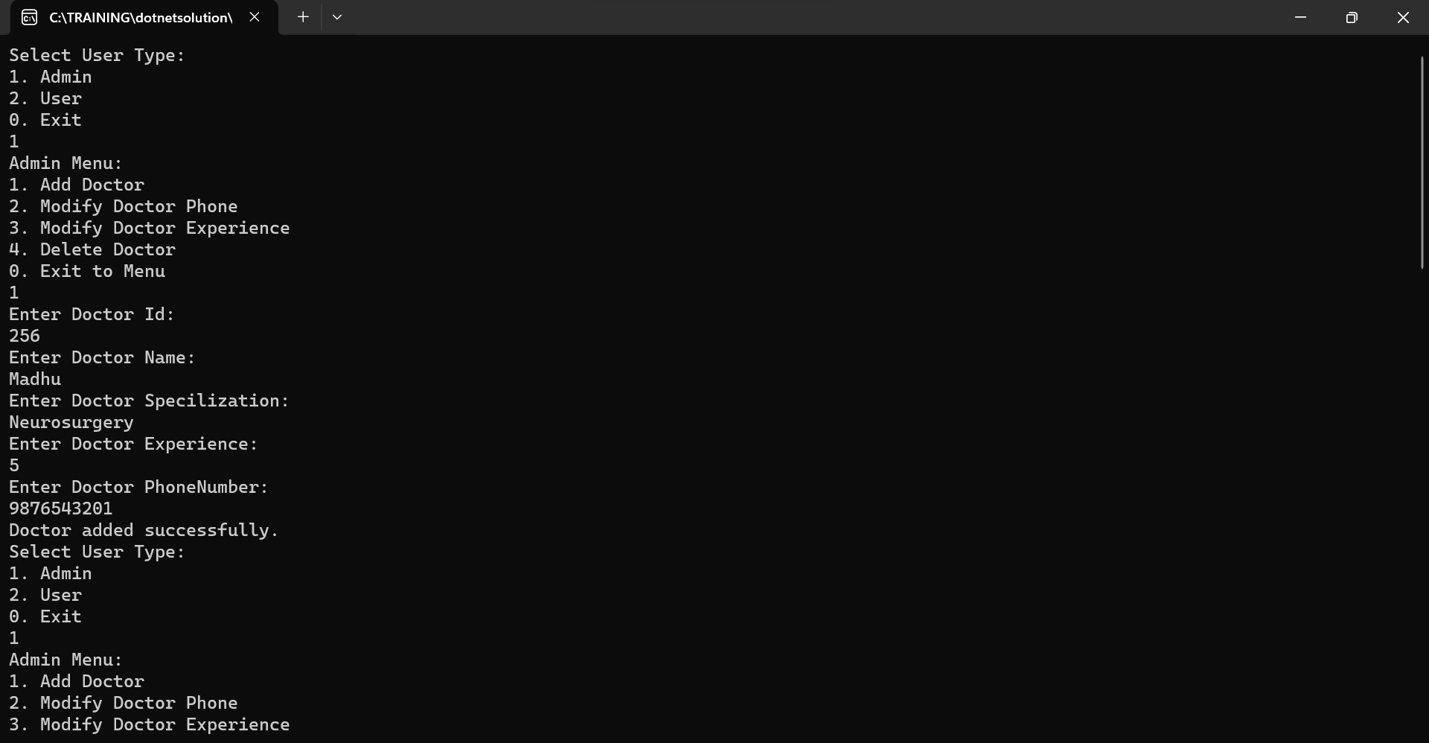

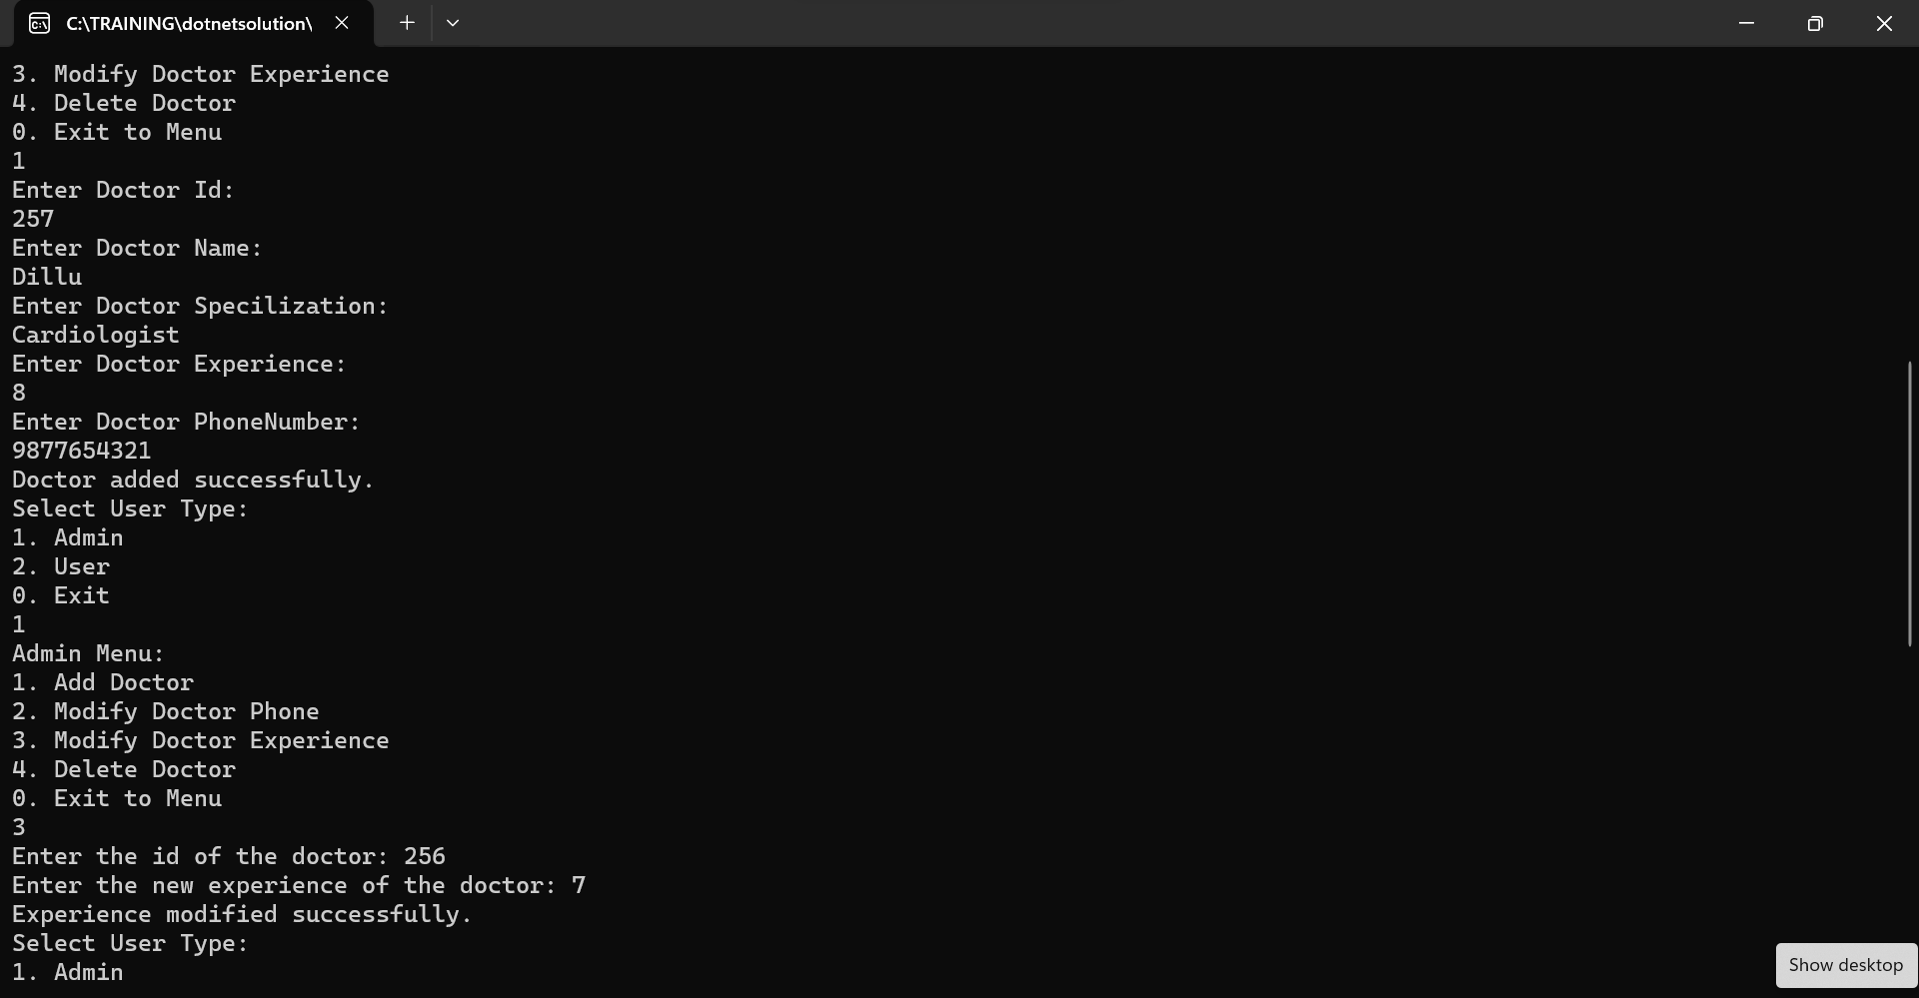

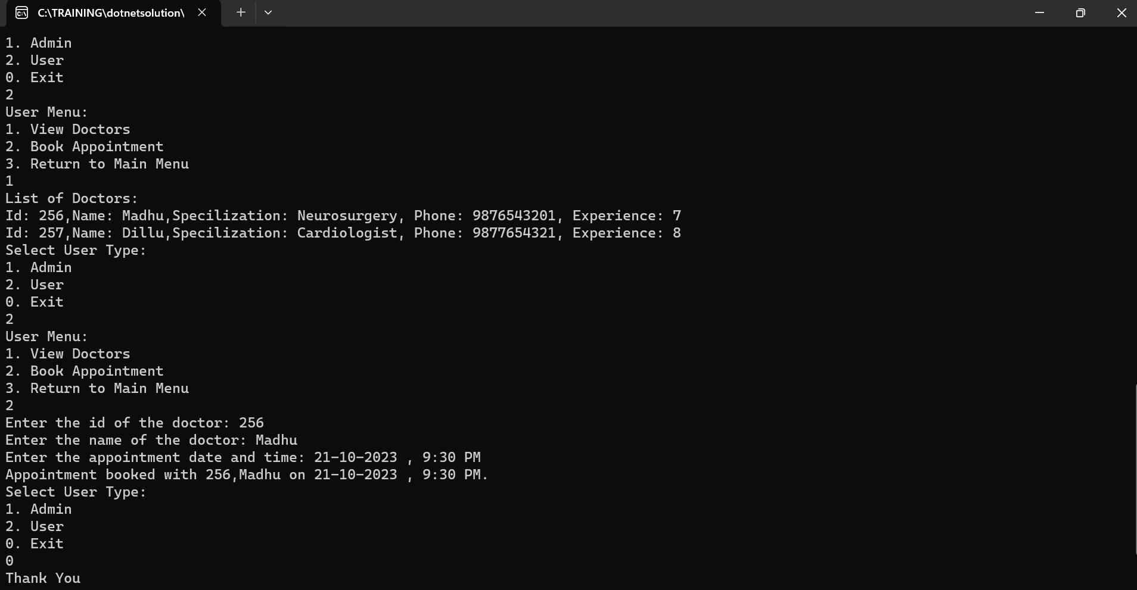

\*\*\*\*THANK YOU\*\*\*\*